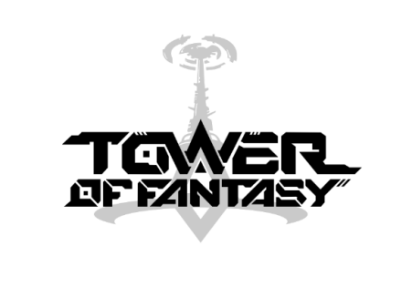

Tower of Fantasy Video Assets (YouTube Links)

- Mini Game Trailer
https://www.youtube.com/watch?v=Eiok-2r_pTQ

- In-game Mount Trailer
https://www.youtube.com/watch?v=QXAnSFTyMNI

- Weapon and Character Trailer
https://www.youtube.com/watch?v=wWaAAV4cfdk

- Character Personalization Trailer
https://www.youtube.com/watch?v=aFmDduoKF-4

- First Announcement PV
https://www.youtube.com/watch?v=3nD3cnNlkyo

- Gameplay Demonstration Video
https://www.youtube.com/watch?v=AOBjW0ng66o

