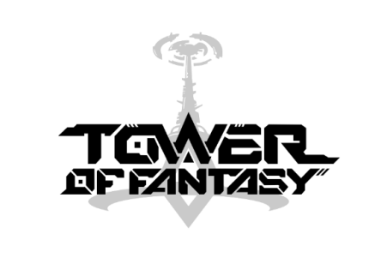

Tower of Fantasy Fact Sheet

- Tower of Fantasy will be released for PC and mobile devices globally Q3, 2022.

- Tower of Fantasy is a shared open-world RPG from Hotta Studio and publisher Level Infinite with a vibrant, anime-inspired art style and exhilarating sci-fi setting. Set hundreds of years in the future on the distant planet of Aida, Tower of Fantasy has been a hit with gamers in China, and in 2022 players from across the globe will get to join in on the thrilling action.

- In Tower of Fantasy, dwindling resources and a lack of energy have forced mankind to leave earth and migrate to Aida, a lush and habitable alien world. There, they observed the comet Mara and discovered an unknown but powerful energy called "Omnium" contained in it. They built the Omnium Tower to capture Mara, but due to the influence of Omnium radiation, a catastrophic disaster occurred on their new homeworld.

- Tower of Fantasy features a deep character customization tool

- The first Closed Beta Test took place from April 18th to May 20th, 2022 and was very successful. Ahead of the full launch, players participating in the Closed Beta were able to explore the game’s open-world setting, experience its thrilling combat and become immersed in its compelling narrative.
  - Some key stats include:
    - Players’ highest average online time in a single day is above 280 minutes;
    - 30% of players who participated in CBT1 played 4 hours every day during the first week.

