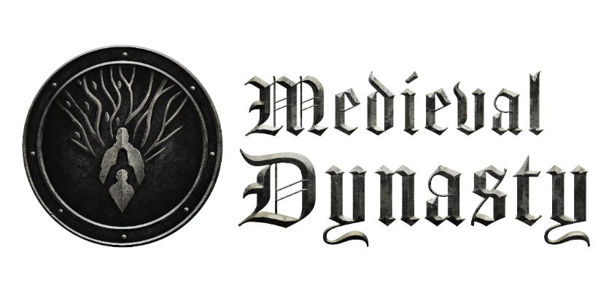


FACTS:
TITLE: MEDIEVAL DYNASTY
PLATFORM: PC
RELEASEDATE: 2020 (Early Access)
PUBLISHER: TOPLITZ PRODUCTIONS - http://toplitz-productions.com/home.html
DEVELOPER: RENDER CUBE
STEAM: http://bit.ly/medieval-dynasty

POSTITIONING:
A UNIQUE AND AUTHENTIC LIFE SIMULATION EXPERIENCE OF MEDIEVAL SURVIVAL,
COMBINED WITH THE BEST ELEMENTS OF RPG AND CITY BUILDER.

KEY PILLARS:
SURVIVE – BUILD - RULE
LIVE & SURVIVE:
- Explore a vast open world of the medieval ages with all its dangers and secrets
- Found a family, have a heir and attract new people to expand your village
- Hunt, farm and cultivate the land to keep yourself and your populace well-fed
BUILD:
- Build a beautiful village that serves the needs of its inhabitants
- Gather resources, craft equipment and weapons and improve your home to withstand the harshness of the time
- Develop your skills and make your character stronger, faster and better
RULE:
- Lead your people through the tough challenges of the medieval ages
- Make the right decisions and directly influence the evolution of your people
- Safeguard your place in history by founding a prodigious dynasty
ABOUT THE GAME:
Medieval Dynasty is a unique combination of various successful genres:
Survival: The need to survive and overcome hunger by hunting, farming and cultivating
Simulation: Crafting equipment and weapons, building and improving houses, animal sheds and other functional and social buildings
RPG: Developing your character, interacting with NPCs, taking care of a family and solving quests for others
Strategy: Foundation and expansion of a village, management of its inhabitants as well as gathering resources, crafting goods and trading them
All this combined and set in a realistic world of medieval times with a FPP view.

STORY IN SHORT:
Europe in the Middle Ages -- Nobles and clergy rule over Europe. Trade between the nations brings not only prosperity but also envy, distrust, and greed.
You are in the role of a poor but skilled hunter and farmer set to take his fate into own hands. Start building a small outpost in the medieval world and develop it into a bustling village. Defend wild animals while on the hunt for food, gather resources and craft equipment to build and improve your home and other buildings of the village. Found a family and take good care of your wife and heirs – and attract new villagers to help you grow and expand your dynasty. Be aware of harsh winters and unexpected events while honing your skills to turn from a medieval survivor into a dynasty ruler.

FEATURES:
- Beautiful and realistic open world 3 D landscape with state of the art graphics
- Full 4 seasons with day/ night cycle and realistic weather conditions
- Interactive environment with trees to fell, various fruit to plug, stones to collect, caves to explore and many more
- 18 different buildings with various levels from hay shacks to full stone mansions
- Over 60 pieces of equipment to craft, including weapons, tools, furniture and clothing
- Realistic wild life interaction with plenty of different animals such as wolfes, wild boars, deer, rabbits and others
- All activities with impact on food, water, health and endurance status
- Detailed skill tree for individual character development
- Unique events and decisions with direct impact on gameplay
- Dynasty reputation system triggering events with the king
- Quests, trade and economy, sandbox option, social connections to NPCs and many more

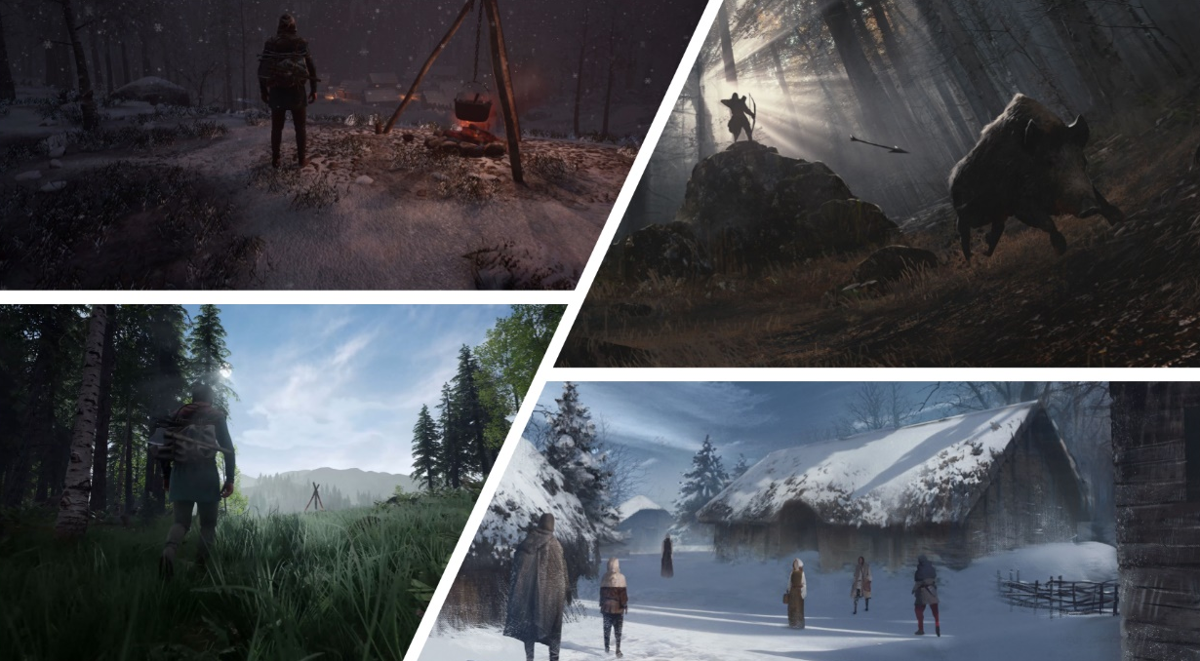

ABOUT TOPLITZ PRODUCTIONS:
Toplitz Productions is an Austrian publisher and developer with one goal - to offer consumers games that feature “Heart and Soul”. The company is comprised of veteran game developers and executives and collaborates with multiple studios throughout the world. Featuring a mix of sports, strategy, adventure, and simulation games, Toplitz's titles can be found on PC and major console platforms, offering something for every type of player.

Keep up with all things related to Toplitz Productions by following the company on Twitter, Facebook, their official website, and Instagram.

ABOUT RENDERCUBE:

Based in Łódź, Poland, Render is a small team of 25 game enthusiasts aiming to create artistic content of the highest quality for game projects across all major platforms.

Together with Toplitz Productions, Render Cube are hard at work on their most ambitious project yet - the historical sandbox life- and survival sim Medieval Dynasty, which quickly became an enormous critical and commercial success after launch.

