Release Date Announcement Trailer
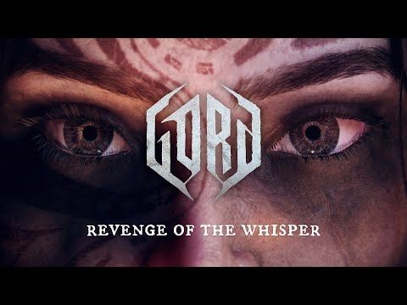

‘They Call It The Gord’ Gameplay Trailer
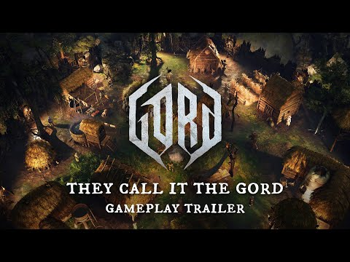

Into the Gord: Episode 1 – The Birth of Gord
Gord – Extended Gameplay Walkthrough
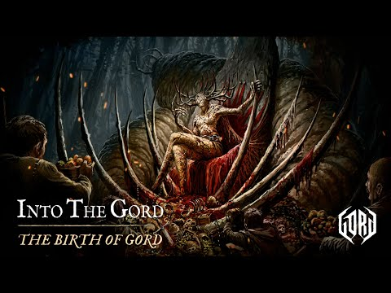

Gord - Teaser Trailer
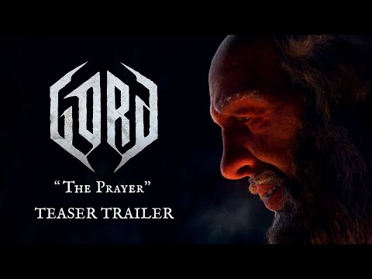
Gord | Official Announcement Trailer
