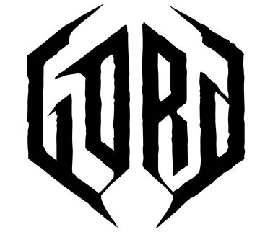
GENERAL INFORMATION
Platforms: PC (Steam), PlayStation 5, Xbox Series X|S
Number of Players: 1
Genres: Dark Fantasy, Strategy, Adventure
Developer: Covenant.dev
Publisher: Team17 Digital
Languages: English, Polish, German, Spanish, Spanish (Latin America), Chinese (Simplified and Traditional), Russian, French, Italian, Japanese, Korean
Release: 8th August 2023
OVERVIEW
Gord is a single-player dark fantasy strategy game. To survive, you must build, but to prevail, you must conquer the darkness beyond the gates. In this dark fantasy world, you must complete quests while managing a populace whose personal stories and well-being decide the fate of your tribe.
KEY FEATURES
- Dark Fantasy Strategy Adventure: Lead the people of the Tribe of the Dawn and venture deep into forbidden lands in a lore-rich, dark fantasy strategy campaign
- Build and Survive: Grow your gord from humble settlement to formidable fortress while protecting your citizens from invading tribes, gruesome monsters, and mysterious powers that lurk within the surrounding woods
- Unique Sanity System: Keep a close eye on your townsfolk as everything from illness to hunger and the death of kin can have devastating impact on their lives and well-being
- Hand-crafted Quests: Take on a wide variety of quests and random encounters that will lead you deep into the wilderness to hunt legendary creatures, uncover ancient secrets, and vanquish deadly scourges
- Unleash Powerful Incantations: Unlock a variety of offensive and defensive spells, each with custom animations, to tip combat in your favour
- Custom Scenarios with Procedurally Generated Levels:
Take on an endless variety of challenges by creating your own scenarios. Customize your playthrough by picking a main objective, choosing your starting party, level size, amount of resources, enemy types, raid intensities, and even the severity of the weather!
IMPORTANT LINKS
Resources: Website - Developer Website - Steam Page - Microsoft Store – PlayStation Store
Social: Twitter - Facebook - Instagram - YouTube - Discord
PRESS CONTACT INFORMATION
Team17 Digital
Abe Foster – abe.foster@team17.com
INFLUENCER RELATIONS CONTACT INFORMATION
Team17 Digital
Matthew Clements – matthew.clements@team17.com

