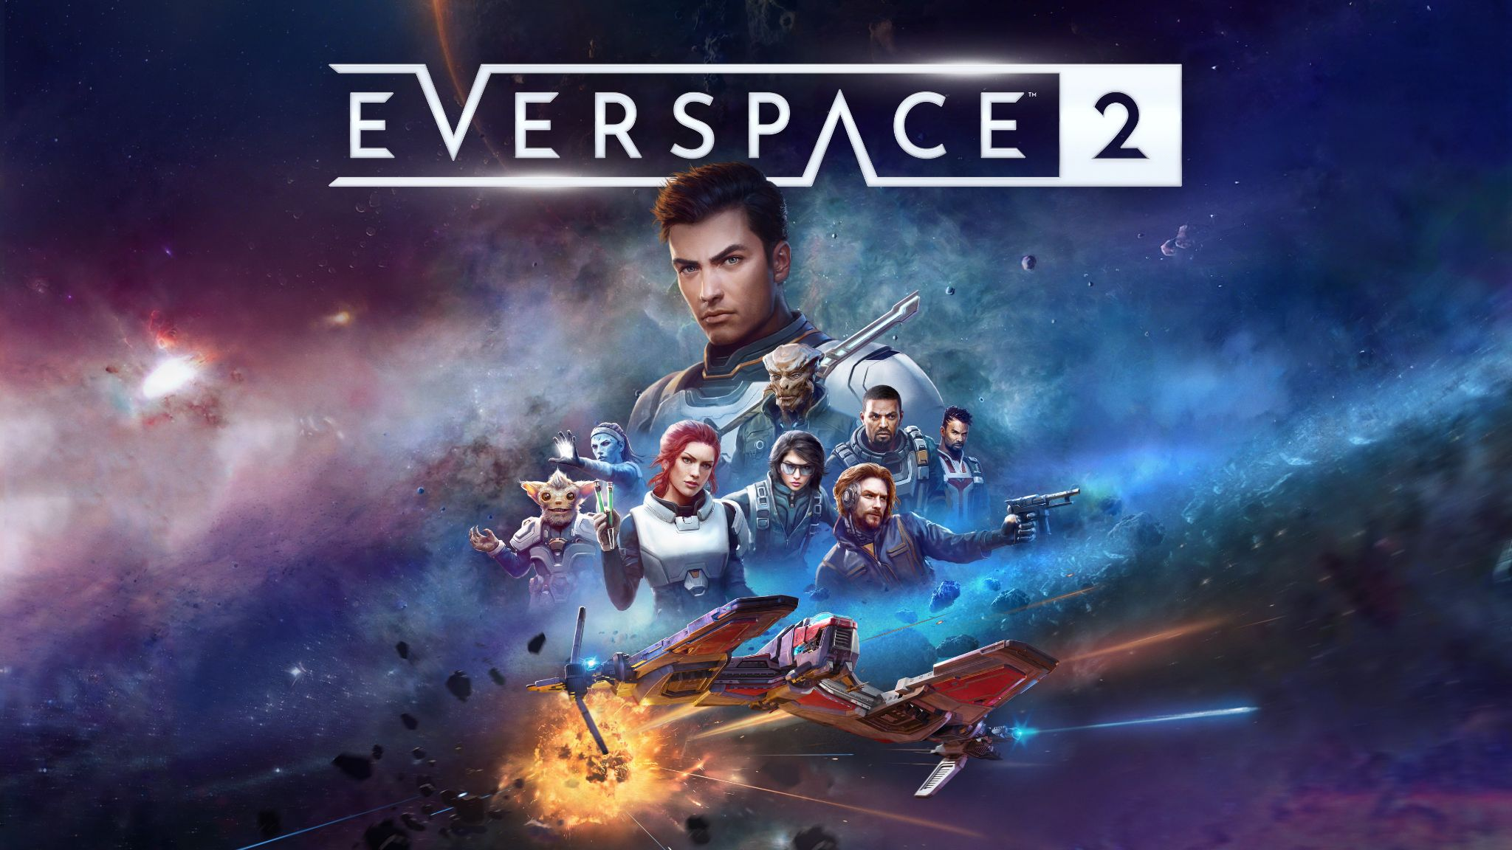

EVERSPACE™ 2 Fact Sheet

PRESS KIT

What is EVERSPACE 2?
EVERSPACE 2 is a fast-paced single-player space shooter with RPG-style progression where vicious encounters and brutal challenges stand between you and the next epic loot drop.
Experience an exciting sci-fi adventure, set in the war-torn star systems of the Demilitarized Zone of Cluster 34, where each massive handcrafted area is packed with secrets, puzzles, and perils to encounter. Dangers await in every corner of the universe—level up, mine, craft, and loot better gear to survive on the edge of space.

What platforms will EVERSPACE 2 be available on?
EVERSPACE 2 will launch on PC platforms on April 6, 2023. A console release on Xbox Series X|S and PlayStation 5 is planned for Summer 2023.
EVERSPACE 2 is currently in PC Game Pass Game Preview and will continue on the service with the full title after launch.

EVERSPACE 2 features at Launch:
- 30+ hours of main campaign story, fully voiced in English and German
- 90+ total hours of exploration including side missions, puzzles, secrets, and location challenges
- 6 semi-open star systems to explore
- 100+ Unique hand-crafted areas
- 9 player ship subclasses featuring 4 tiers, each class with their own perks and ultimate abilities
- 7 different factions to encounter, each with multiple distinctive enemy ship and defensive unit types with their own abilities
- 7 companions to recruit, each with their own set of upgradable perks
- A massive array of customization options for each ship, plus unlockable transmogging
- Collectable blueprints unlocking crafting and dismantling options
- Hundreds of different equippable weapon and gear types
- Ancient Rifts endgame content where players push their luck against increasingly difficult waves of enemies to unlock powerful legendary weapons and gear, each with a unique property
- A wide variety of radiant faction jobs that unlock valuable reputation bonuses
- Fully customizable PC HOTAS/HOSAS controller support

What languages and localization is EVERSPACE 2 in?
EVERSPACE 2 will be fully voiced in English and German. The game will include text localization and subtitles in English, Brazilian Portuguese, Czech, French, German, Italian, Japanese, Korean, Polish, Russian Simplified and Traditional Chinese, and Spanish.

What PC system specs does EVERSPACE 2 require?

MINIMUM
OS: Windows 10 64-bit
Processor: Intel Core i5-2500K@2.9GHz or AMD FX 6300@2.9GHz
Memory: 8GB RAM
Graphics: Nvidia GeForce GTX 780 (3GB) or AMD Radeon R9 290 (4GB)
DirectX: Version 11
Storage: 50GB available space
This game is in Early Access; minimum specifications may change during development.

RECOMMENDED
OS: Windows 10 64-bit
Processor: Intel Core i7-4770K@3.5GHz or Ryzen 5 1500X@3.5GHz
Memory: 16GB RAM
Graphics: Nvidia GeForce GTX 1060 (6GB) or AMD Radeon RX 580 (8GB)
DirectX: Version 12
Storage: 50GB available space

Contact Information:
ROCKFISH Games Press and Content Creator Contact
Lee Guille, ROCKFISH Games Communications & PR Director
Email: Lee@rockfishgames.com
Twitter: @writeleewrite

North America and LATAM
Evolve PR
Charles Singletary Jr. - charlesjr@evolve-pr.com

Germany and Europe that is not Nordics or France
Swordfish PR
Freyja Melhorn - freyja@swordfish-pr.de

UK, UK, Ireland, Australia, New Zealand, South Africa, Denmark, Sweden, Norway, and Finland
Plan of Attack
Laura Pa - laura@planofattack.biz

France
Warning Up
Ambre Kummer - a.kummer@warningup.com

Yann Roskell - y.roskell@warningup.com

Japan
Active Gaming Media
Jeremy Bouvard - jeremy.bouvard@activegamingmedia.com

Poland and Czech Republic
Kool Things
Greg Wilpiszewski - grzegorz.wilpiszewski@koolthings.com

Russia
Fat Pony
Nikolay Borzov - borzov@fatpony.ru
Georgii Shersheriia - georgii.shersheriia@fatpony.ru

ROCKFISH Games Social Media
- ROCKFISH Games Twitter
- EVERSPACE 2 Twitter
- ROCKFISH Games Facebook
- EVERSPACE 2 Facebook
- YouTube
- Linkedin
- Studio Website
- EVERSPACE 2 Website

