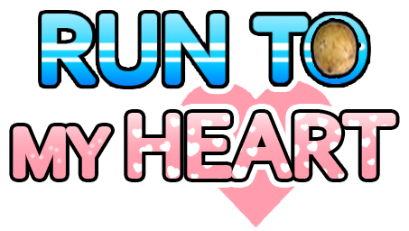
Run to My Heart is a real world social running game built on the Niantic Real World Platform and winner of the Niantic Beyond Reality Contest. Set in a diseased world where humans turn into potatoes if they don’t run, Run to My Heart encourages exploration and exercise with friends to survive. As a member of the Potato Rescue Squad, you’ll run with friends to find potions in the real world that can help cure the humans-turned-potatoes. Plug in your headphones and virtual running companions will coach you to stay on pace, identify locations as you approach them, and disclose stories about the mysterious potato disease and themselves. Then it’s time to stretch! Turn the potatoes back into humans by battling giant mutant hamsters in AR by extending your arms to block attacks, pick up items, and fight back. Now go out there, and save those potatoes!

Key Features:
- Run! - Get off the couch and run in the real world to gather potions and help save the humans -- or else you’ll turn into a potato
- Audio Running Coaching - Plug in your headphones and get motivated to run faster with updates on pacing and dynamic information on your surroundings from your personal running companions
- Interactive Story - Uncover more of the narrative behind the potato disease the more and the longer you run with your running companions
- AR Stretch Battles - After your run, use the AR camera and stretch to block attacks from giant mutant hamsters and throw water balloons back -- simultaneously reducing the risk of real world injuries
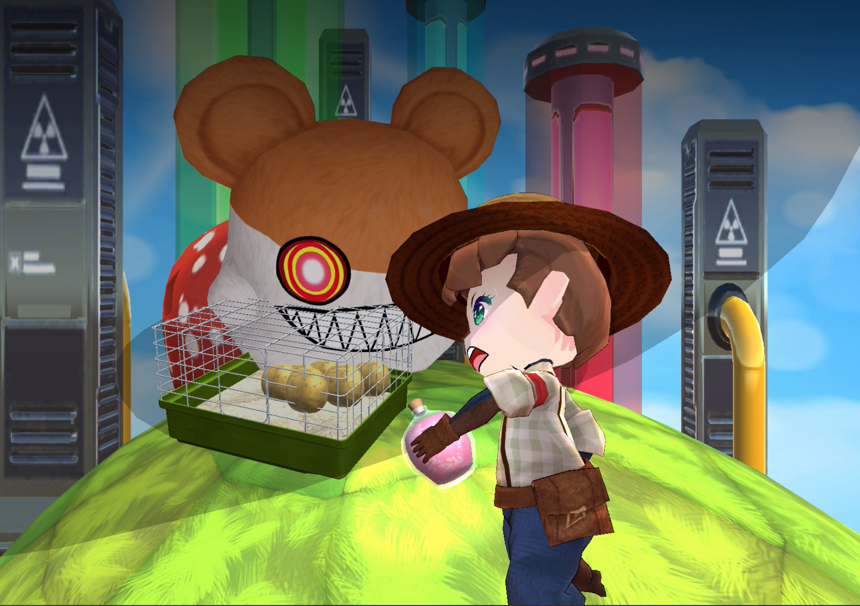
- Work Together - Coordinate runs with friends to collect potions and work together in battles

