Uragun Full Release Out Now!
Rogulite mecha shooter from Warsaw-based studio, Kool2Play, is available on Steam!
The launch follows 12 months of EA and brings player-requested roguelite gameplay and structure. Uragun will be available from 6 pm CEST (9 am PST) in its full release for $10.49 (also €10.49) discount for a limited time!
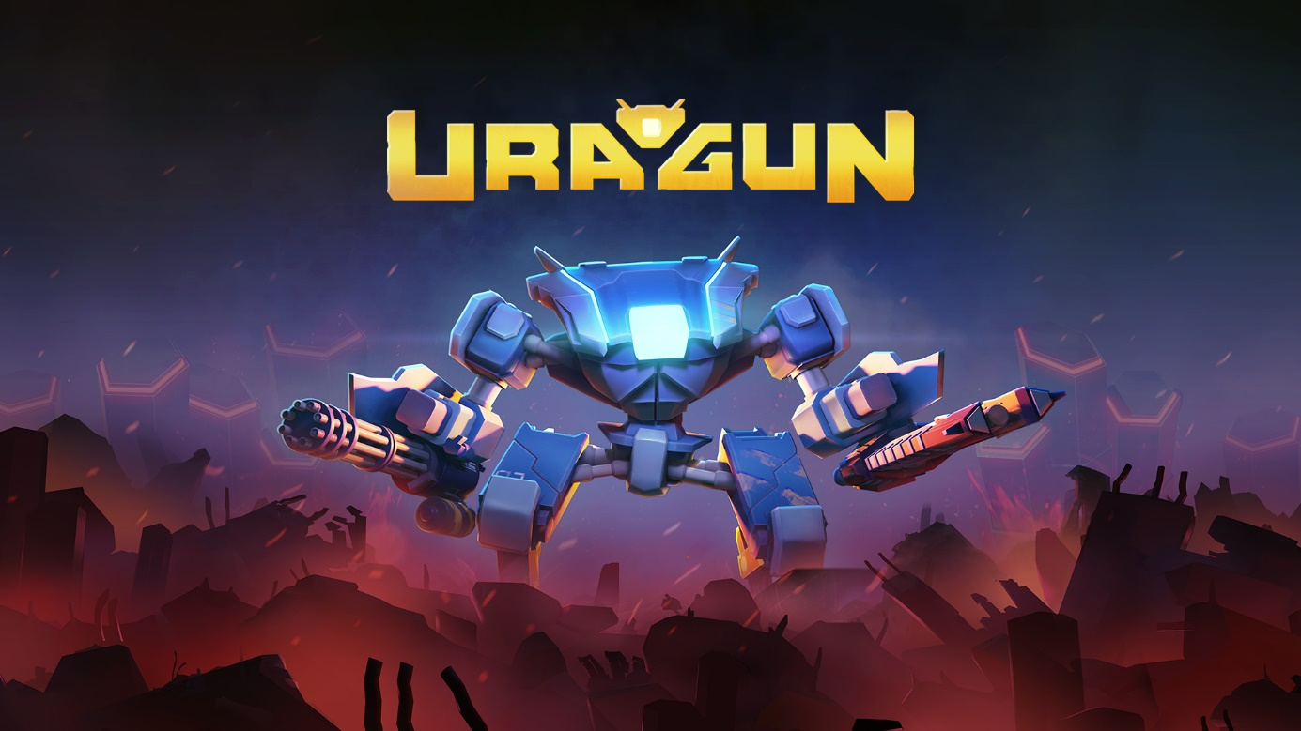
TL;DR
- Uragun roguelite 1.0 full release is going live today!
- What has changed since Steam Early Access 2022:
  - Game structure (and genre!) has been pivoted into roguelite shooter,
  - We added new biomes, boss fights, tons of enemies, upgrades, perks and even skins so you can customize your Mech the way you want!
- Uragun’s most distinct features:
  - Customizable and moddable mech roguelite shooter with great replayability
  - Top-notch shooting, controls and gameplay
  - Charming story of the Mech looking for its missing pilot friend
  - Deadly and satisfying combos due to modding and plugin system
  - Hand-crafted levels tailored for intense and tightly measured challenges
- Press Kit: here
Warsaw, March 30, 2023 – Independent game developer Kool2Play is proud to announce that after careful consideration of EA launch and precious feedback from our players, the team worked really hard to pivot Uragun into a roguelite and it proved to be a better fit for our game. Everything that players loved about Uragun (super tight controls, fun and exciting combat, clever level design etc) is now supported with a bunch of mechanics that support replayability and Uragun is more fun than ever!
After a total gameplay makeover directed by Fran Avilés (previously responsible for Deep Rock Galactic) as Game Director, Kool2Play can finally present their final version and ultimately fun action-packed roguelite shooter. The launch trailer of the game can be found here!
In Uragun you play as a charming Mech unit that has awakened to discover a world overrun by corrupted AI. Choose your path and rewards allowing you to research new skills, mod your Mech and its weapons and grow stronger. And yes, you can also play with your Mech looks!
The search for your missing pilot friend will bring you to different spectacular locations where the impact of the AI upraising changed the world as we know it. Every fight will take place in a selected location of this beautiful and devastated world. Your quest will bring you to places like a deserted Barcelona, Industrialized Nairobi, the mines hidden in the snowy mountain rifts of North America or an overgrown and futuristic Hong Kong.
Once the Mech is defeated, it will be reprinted on the Orbital Station that acts as your main hub. Modifications for weapons and other perks will be gone. However, the Intel that you have collected will be useful here to acquire permanent upgrades from the Research Tree. These upgrades will increase your survivability, attack or add some nice extras for the run in the form of Expansion Cartridges. However, not all of them can be equipped at once since your Memory capacity is limited. You’ll have to choose Expansion Cartridges wisely based on your preferred playstyle and strategy. Luckily, Memory capacity can also be increased, giving you a chance of stacking more of the Expansion Cartridges in the future.
During a run, the Mech unit can be improved in different ways. Plugins will add new skills, improve some of the stats or enhance your special Heat Attacks. They can be leveled up for an even stronger effect. Additionally, weapon mods are special effects that can be equipped on weapons with available slots. Experiment with their effects on every weapon type and combine them to create your favorite build. More than one weapon mod of the same type can be stacked to increase the intensity of the effects.
At launch game will be available in Polish, English, Spanish, German, French, Brazilian Portuguese, Chinese Simplified, Japanese, Korean and Turkish.
We know it may seem like we went under the radar for a while, but the truth is, that we worked really hard to pivot Uragun into a roguelite – said Mariusz Leśniewski, the Head of Studio at Kool2Play. We are super happy to be back with the final product and share it now with you and our players as we think our game really shines now!
You can find some more information on the whole redesign process and its reasoning in historical change of direction post and recent roguelite beta announcement.
The devs also invite everyone to join the official Uragun server on Discord – to meet community members here, chat with producers, and leave valuable feedback. Every comment is taken into account!
Follow the game om social media: Facebook and Twitter, and Kool2Play social media channels: Facebook, Twitter and Instagram. More info about the game can be found on Steam, Kool2Play and game webpage. Gameplay material, trailers and other video assets can be found on Kool2Play YouTube channel.
Press assets can be found here.

About Kool2Play Group:
Kool2Play is a unique developer and publisher of games operating in a wide range of genres. We create games that are primarily fun, playable, and focus on quality. In parallel with the work on the game Uragun, we are creating two productions planned for the coming years, codenamed Project X and Project Y. Kool2Play Group includes also two other companies: Kool Things – one of the most experienced agencies specializing in the international game promotion and Buffmaker - a software platform for automation, processing, and analytics of marketing data.

